**Table S1. Full results including model building procedures.**

|  |  |  |  |
| --- | --- | --- | --- |
|  | **Control only** | **Control + Structural** | **Final Model** |
| Edges (Intercept) | **-4.977** [-6.749; -6.749]* | **-1.127** [-2.206; -2.206]* | **-1.890** [-2.932; -1.392]* |
| ***Motivation and Homophily*** |  |  |  |
| Consistency motivation (in-ties) |  |  | **.034** [.009; .113]* |
| Consistency motivation (out-ties) |  |  | .025 [-.044; .077] |
| Understanding motivation (in-ties) |  |  | -.052 [-.080; .022] |
| Understanding motivation (out-ties) |  |  | **.028** [.005; .076]* |
| Hedonic motivation (in-ties) |  |  | -.012 [-.029; .001] |
| Hedonic motivation (out-ties) |  |  | **.102** [.087; .133]* |
| Same candidate preference |  |  | -.032 [-.070; .047] |
| Similar policy preference |  |  | -.108 [-.212; .006] |
| Similar evaluative criteria |  |  | **.407** [.399; .415]* |
| ***Endogenous structural effects*** |  |  |  |
| Isolates |  | **1.021** [.797; .797]* | **1.019** [.908; 1.264]* |
| Reciprocity |  | **.765** [.497; .497]* | **.769** [.564; 1.068]* |
| Multiple path closure (GWESP-OTP) |  | **.058** [-.056; -.056]* | .058 [-.053; .125] |
| Multiple cyclic closure (GWESP-ITP) |  | **-.068** [-.082; -.082]* | **-.066** [-.080; -.060]* |
| Multiple activity closure (GWESP-OSP) |  | **.035** [.030; .030]* | **.036** [.033; .045]* |
| Multiple popularity closure (GWESP-ISP) |  | **.117** [.083; .083]* | **.115** [.093; .232]* |
| Multiple two-paths (GWDSP) |  | **.003** [-.005; -.005]* | .003 [-.007; .007] |
| Activity spread (GW-outdegree) |  | **-4.399** [-4.669; -4.669]* | **-4.350** [-4.557; -4.157]* |
| Popularity spread (GW-indegree) |  | **-4.056** [-5.343; -5.343]* | **-4.049** [-5.342; -3.259]* |
| ***Lagged structural effects*** |  |  |  |
| Previous communication |  | **.214** [.182; .182]* | **.222** [.192; .253]* |
| Delayed reciprocity |  | **.082** [-.067; -.067]* | .074 [-.073; .194] |
| Delayed transitivity closure |  | **.034** [.018; .018]* | **.034** [.020; .055]* |
| Delayed cyclic closure |  | **.037** [.010; .010]* | **.034** [.008; .057]* |
| Delayed activity closure |  | **-.058** [-.068; -.068]* | **-.056** [-.067; -.046]* |
| Delayed popularity closure |  | **-.060** [-.089; -.089]* | **-.059** [-.110; -.043]* |
| Persistent sender (out-tie) |  | **.019** [.009; .009]* | **.019** [.010; .029]* |
| Persistent receiver (in-ties) |  | **.023** [.019; .019]* | **.023** [.018; .038]* |
| ***Controls*** |  |  |  |
| Age (in-ties) | **.101** [-.012; -.012]* | **.003** [-.017; -.017]* | .001 [-.020; .022] |
| Age (out-ties) | **.218** [-.097; -.097]* | **.031** [-.224; -.224]* | .052 [-.105; .093] |
| Female (in-ties) | **-.204** [-.245; -.245]* | **-.001** [-.038; -.038]* | .005 [-.036; .041] |
| Female (out-ties) | **-.169** [-.446; -.446]* | **.075** [-.308; -.308]* | .014 [-.348; .254] |
| Gender homophily | **.010** [-.032; -.032]* | **.051** [.018; .018]* | **.044** [.023; .086]* |
| Education (in-ties) | **-.114** [-.182; -.182]* | **-.008** [-.042; -.042]* | -.011 [-.039; .019] |
| Education (out-ties) | **-.132** [-.239; -.239]* | **.028** [-.010; -.010]* | .016 [-.015; .091] |
| Regional origin = Seoul (in-ties) | **-.418** [-.501; -.501]* | **-.077** [-.116; -.116]* | -.084 [-.130; .044] |
| Regional origin = Seoul (out-ties) | **-.192** [-.383; -.383]* | **-.143** [-.635; -.635]* | -.125 [-.438; .350] |
| Regional homophily (Seoul) | **-.021** [-.047; -.047]* | **.013** [-.020; -.020]* | .017 [-.014; .080] |
| Offline talk frequency (in-ties) | **.129** [-.120; -.120]* | **.045** [.021; .021]* | **.046** [.024; .049]* |
| Offline talk frequency (out-ties) | **.025** [-.428; -.428]* | **.034** [-.173; -.173]* | .014 [-.099; .161] |
| Media use (in-ties) | **-.061** [-.108; -.108]* | **-.011** [-.021; -.021]* | **-.011** [-.019; -.003]* |
| Media use (out-ties) | **-.070** [-.104; -.104]* | **.040** [.004; .004]* | .033 [-.017; .071] |
| Internal efficacy (in-ties) | **.051** [-.045; -.045]* | **-.013** [-.040; -.040]* | -.013 [-.058; .055] |
| Internal efficacy (out-ties) | **.187** [.132; .132]* | **-.018** [-.098; -.098]* | .024 [-.102; .128] |
| Candidate preference = Moon (in-ties) | **.174** [.057; .057]* | **-.018** [-.063; -.063]* | .003 [-.008; .092] |
| Candidate preference = Moon (out-ties) | **.315** [.216; .216]* | **-.010** [-.100; -.100]* | .013 [-.123; .066] |
| Num. obs. | 291096 | 291096 | 291096 |
| * = zero outside the 95% bias-corrected and accelerated confidence interval based on 1000 replications.  Decay (alpha) values for each geometrically weighted term are: GWESP-OTP = 3, GWESP-ITP = 3, GWESP-OSP = 3, GWESP-ISP = 2, GWDSP = 1, GW-outdegree = 2, and GW-indegree = 3. | | | |

**Table S2. Full results including interactions.**

|  |  |  |  |
| --- | --- | --- | --- |
|  | **Interaction I** | **Interaction II** | **Interaction III** |
| Edges (Intercept) | **-1.819** [-2.732; -.304]* | **-1.823** [-2.807; -1.169]* | **-1.936** [-2.937; -1.098]* |
| ***Motivation and Homophily*** |  |  |  |
| Consistency motivation (in-ties) | .037 [-.004; .113] | **.037** [.010; .113]* | **.037** [.010; .113]* |
| Consistency motivation (out-ties) | .019 [-.112; .071] | .019 [-.112; .071] | .019 [-.043; .071] |
| Understanding motivation (in-ties) | -.049 [-.103; .022] | -.049 [-.103; .022] | -.049 [-.078; .022] |
| Understanding motivation (out-ties) | **.036** [.012; .075]* | **.035** [.011; .087]* | **.035** [.011; .075]* |
| Hedonic motivation (in-ties) | -.012 [-.038; .001] | -.013 [-.032; .001] | -.013 [-.038; .001] |
| Hedonic motivation (out-ties) | **.102** [.094; .130]* | **.102** [.096; .130]* | **.102** [.094; .105]* |
| Same candidate preference | **-.135** [-.211; -.111]* | -.033 [-.079; .047] | -.032 [-.079; .047] |
| Similar policy preference | -.091 [-.225; .042] | -.090 [-.230; .042] | .094 [-.764; .272] |
| Similar evaluative criteria | **.385** [.260; .404]* | .295 [-.359; .639] | **.389** [.255; .405]* |
| ***Interaction effects*** |  |  |  |
| Time trends (linear) | .079 [-.059; .262] | **.083** [.021; .171]* | **.144** [.063; .235]* |
| xSame candidate preference | **.051** [.038; .071]* |  |  |
| xSimilar evaluative criteria |  | .046 [-.176; .242] |  |
| xSimilar policy preference |  |  | -.095 [-.253; .214] |
| ***Endogenous structural effects*** |  |  |  |
| Isolates | **1.003** [.793; 1.264]* | **1.005** [.793; 1.152]* | **1.005** [.895; 1.264]* |
| Reciprocity | **.768** [.560; 1.068]* | **.768** [.559; 1.068]* | **.768** [.507; 1.068]* |
| Multiple path closure (GWESP-OTP) | .057 [-.053; .094] | .057 [-.053; .125] | **.057** [.025; .125]* |
| Multiple cyclic closure (GWESP-ITP) | **-.066** [-.076; -.061]* | **-.066** [-.076; -.061]* | **-.066** [-.080; -.061]* |
| Multiple activity closure (GWESP-OSP) | **.035** [.033; .043]* | **.035** [.033; .041]* | **.035** [.033; .043]* |
| Multiple popularity closure (GWESP-ISP) | **.113** [.083; .232]* | **.113** [.083; .232]* | **.113** [.098; .232]* |
| Multiple two-paths (GWDSP) | .003 [-.007; .007] | .003 [-.007; .007] | .003 [-.007; .009] |
| Activity spread (GW-outdegree) | **-4.395** [-4.557; -4.153]* | **-4.392** [-4.557; -4.152]* | **-4.392** [-4.557; -3.994]* |
| Popularity spread (GW-indegree) | **-4.123** [-5.342; -3.541]* | **-4.120** [-5.342; -3.537]* | **-4.121** [-4.810; -3.259]* |
| ***Lagged structural effects*** |  |  |  |
| Previous communication | **.220** [.184; .250]* | **.220** [.184; .250]* | **.219** [.185; .250]* |
| Delayed reciprocity | .076 [-.073; .289] | .075 [-.073; .257] | .076 [-.073; .257] |
| Delayed transitivity closure | **.033** [.019; .051]* | **.033** [.019; .051]* | **.033** [.019; .051]* |
| Delayed cyclic closure | **.032** [.008; .041]* | **.032** [.008; .057]* | **.032** [.008; .043]* |
| Delayed activity closure | **-.055** [-.060; -.035]* | **-.055** [-.065; -.035]* | **-.055** [-.065; -.035]* |
| Delayed popularity closure | **-.058** [-.081; -.034]* | **-.058** [-.110; -.043]* | **-.058** [-.081; -.034]* |
| Persistent sender (out-tie) | **.019** [.010; .029]* | **.019** [.010; .025]* | **.019** [.010; .025]* |
| Persistent receiver (in-ties) | **.023** [.018; .038]* | **.023** [.018; .038]* | **.023** [.021; .038]* |
| ***Controls*** |  |  |  |
| Age (in-ties) | -.003 [-.023; .020] | -.003 [-.022; .035] | -.003 [-.022; .020] |
| Age (out-ties) | .040 [-.192; .091] | .040 [-.112; .090] | .040 [-.113; .090] |
| Female (in-ties) | .009 [-.037; .043] | .009 [-.036; .071] | .009 [-.036; .071] |
| Female (out-ties) | .029 [-.348; .268] | .029 [-.348; .268] | .029 [-.348; .335] |
| Gender homophily | **.044** [.015; .070]* | **.044** [.015; .086]* | **.044** [.022; .086]* |
| Education (in-ties) | -.010 [-.029; .019] | -.010 [-.029; .019] | -.010 [-.029; .018] |
| Education (out-ties) | .015 [-.016; .073] | .015 [-.016; .072] | .015 [-.016; .071] |
| Regional origin = Seoul (in-ties) | -.083 [-.157; .044] | -.084 [-.131; .044] | **-.084** [-.157; -.031]* |
| Regional origin = Seoul (out-ties) | -.143 [-.598; .350] | -.142 [-.450; .350] | -.143 [-.449; .350] |
| Regional homophily (Seoul) | .015 [-.014; .048] | .015 [-.014; .080] | .015 [-.014; .080] |
| Talk freq (in-ties) | **.030** [.018; .037]* | **.030** [.018; .036]* | **.030** [.002; .037]* |
| Talk freq (out-ties) | -.005 [-.097; .161] | -.006 [-.130; .161] | -.006 [-.143; .110] |
| Media use (in-ties) | **-.018** [-.024; -.002]* | **-.018** [-.024; -.002]* | -.018 [-.024; .000] |
| Media use (out-ties) | **.024** [.001; .287]* | .024 [-.017; .075] | .024 [-.017; .074] |
| Internal efficacy (in-ties) | -.012 [-.058; .055] | -.012 [-.058; .055] | -.012 [-.042; .055] |
| Internal efficacy (out-ties) | .030 [-.102; .128] | .031 [-.064; .128] | .031 [-.102; .128] |
| Candidate pref = Moon (in-ties) | .006 [-.008; .049] | .004 [-.008; .092] | .003 [-.008; .092] |
| Candidate pref = Moon (out-ties) | .017 [-.123; .070] | .017 [-.123; .070] | .016 [-.063; .131] |
| Num. obs. | 291096 | 291096 | 291096 |
| * = zero outside the 95% bias-corrected and accelerated confidence interval based on 1000 replications.  Decay (alpha) values for each geometrically weighted term are: GWESP-OTP = 3, GWESP-ITP = 3, GWESP-OSP = 3, GWESP-ISP = 2, GWDSP = 1, GW-outdegree = 2, and GW-indegree = 3. | | | |

**Figure S1. The Goodness-of-fit (*gof*) assessment of final model specification.**

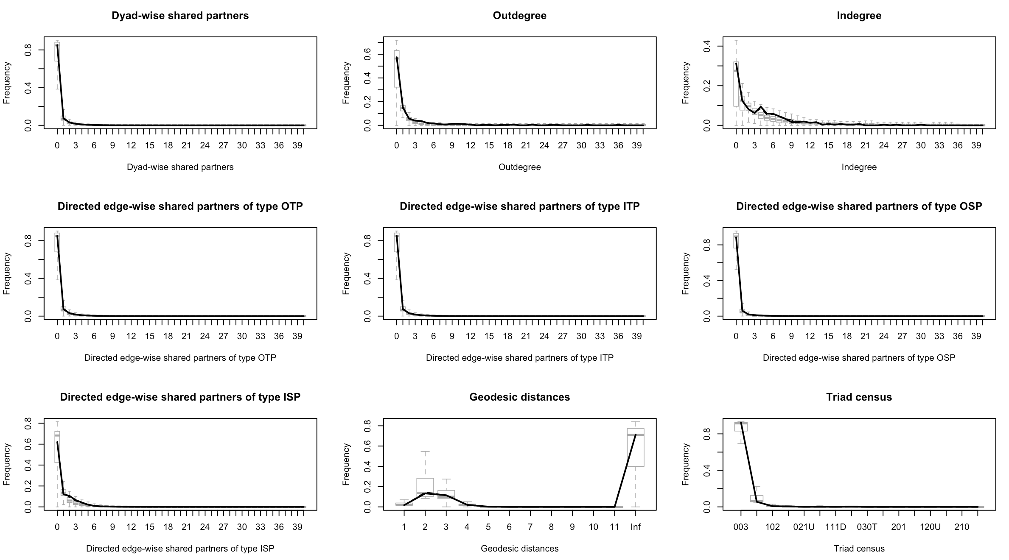

**Figure S2. Parameter estimates and 95% confidence intervals from the final model.**

Panel A: Key Predictors (Significant model terms are denoted in red)

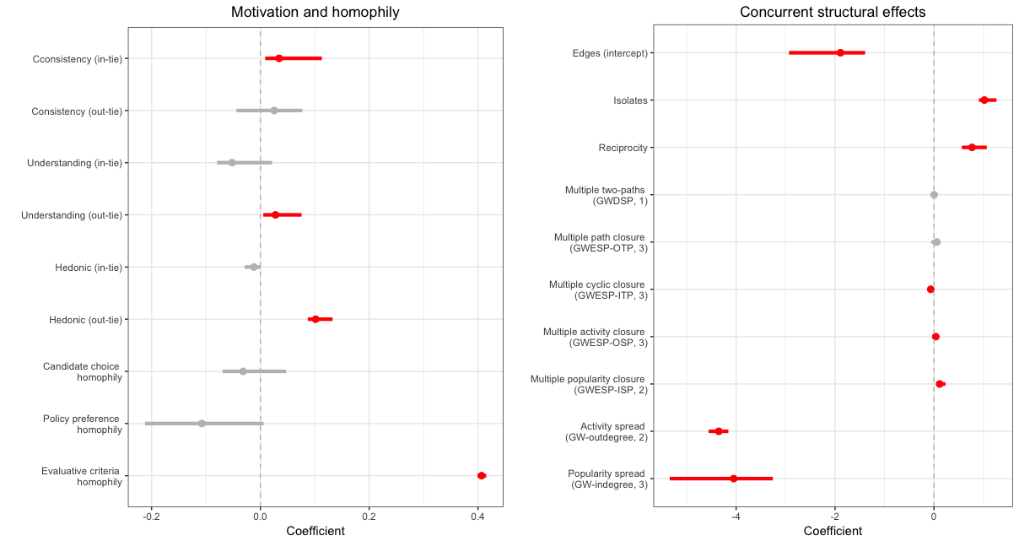

**Figure S2. Parameter estimates and 95% confidence intervals from the final model (continued).**

Panel B: Control Variables (Significant model terms are denoted in red)

